NAME :Jacinth Priscilla.J

REG NO:192311055

Class Exercise – Unit II

Date:30/04/25

1. Create an HTML form to input 3 subject marks. Use JavaScript to:

Calculate the average (use arithmetic operators)

Display grade using ternary operators:

o A: ≥ 90

o B: 75–89

o C: 50–74

o F: &lt; 50

Also check if the student failed in any subject using logical operators.

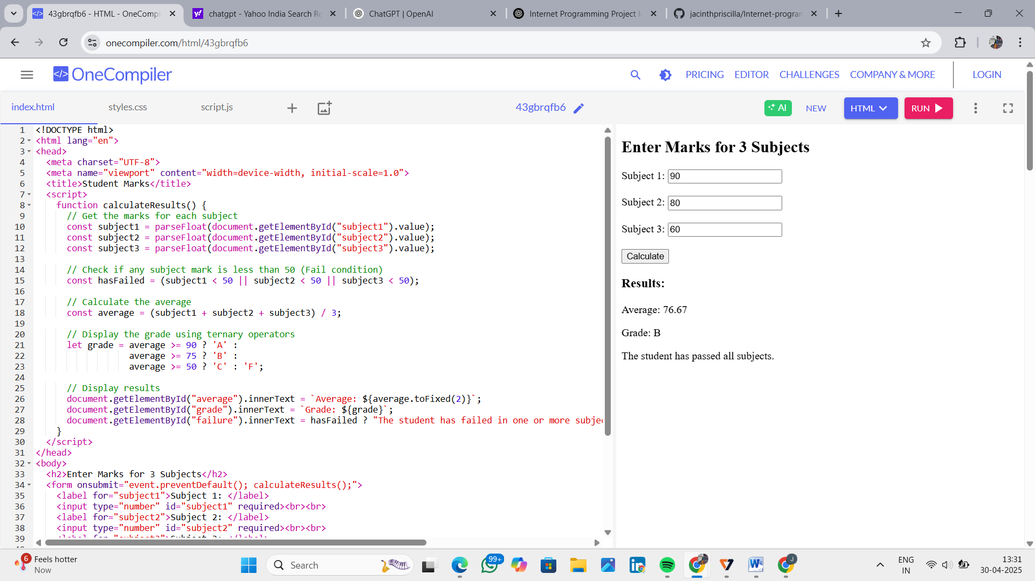

2. Design a calculator interface with:

Two inputs and buttons for: +, -, \*, /, %, \*\*

Show the result in a &lt;div&gt;

Use switch-case or if-else to handle different operations

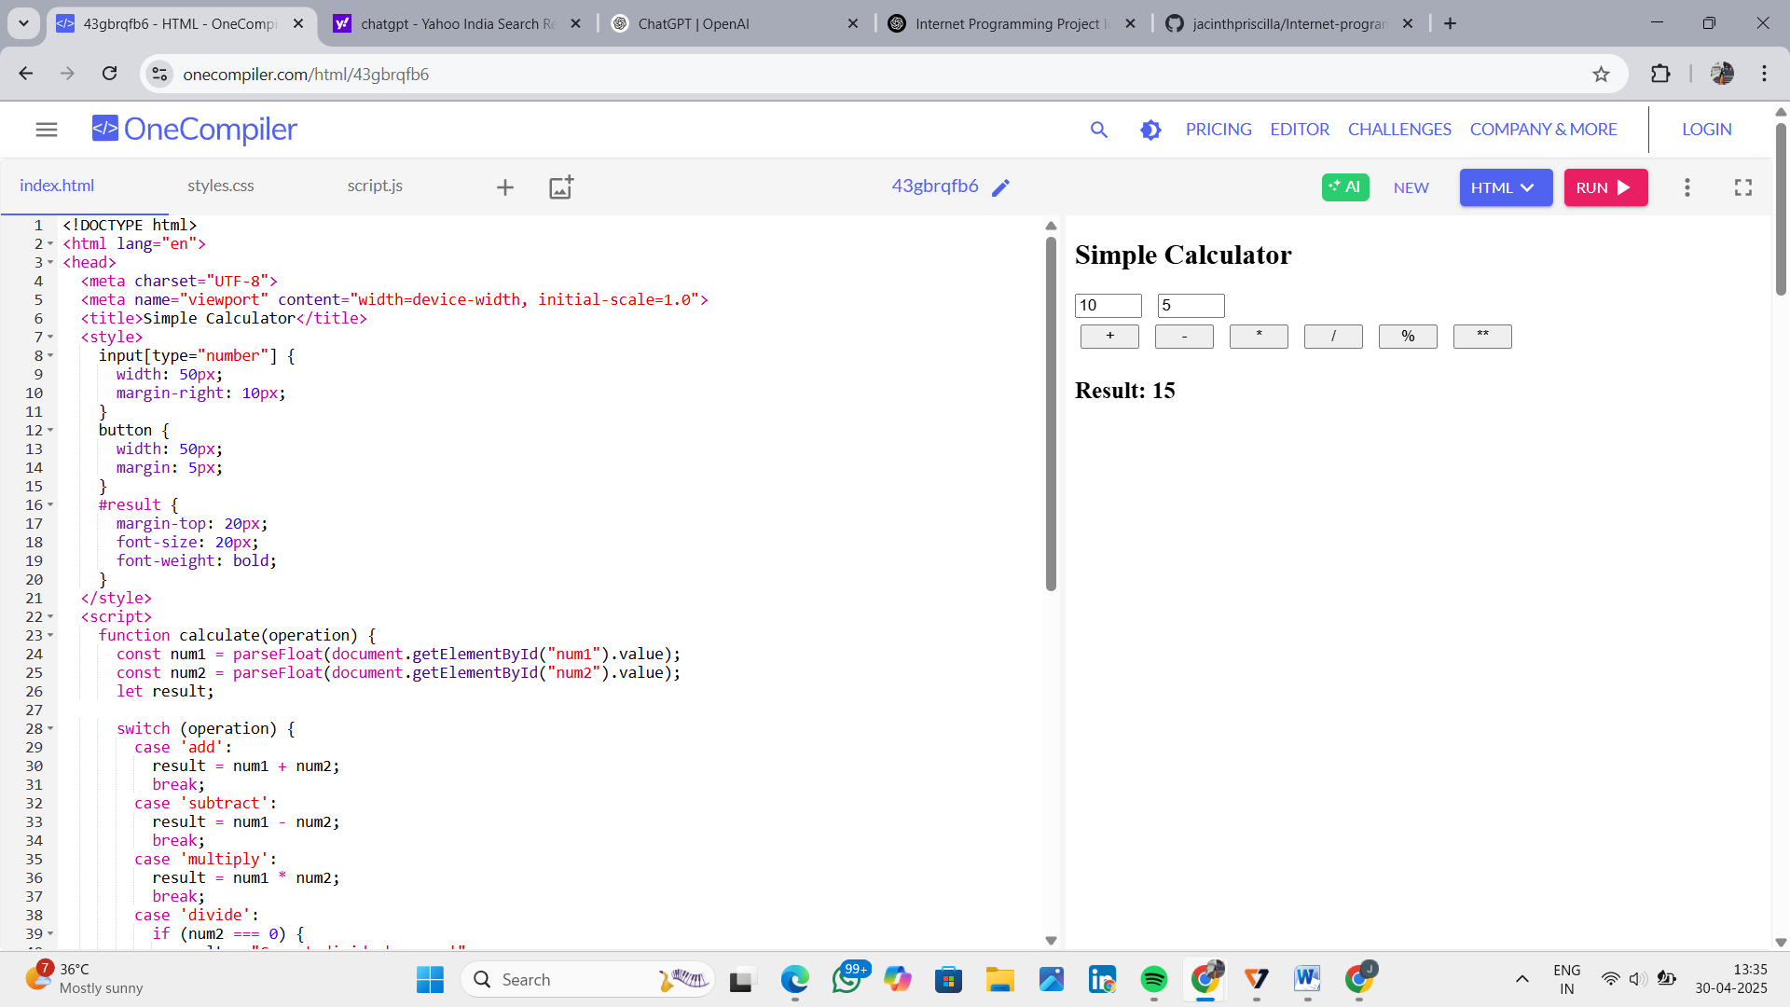

3. Create an HTML form that accepts name and email from the user, and on submit, convert the data

into a JSON string and display it.

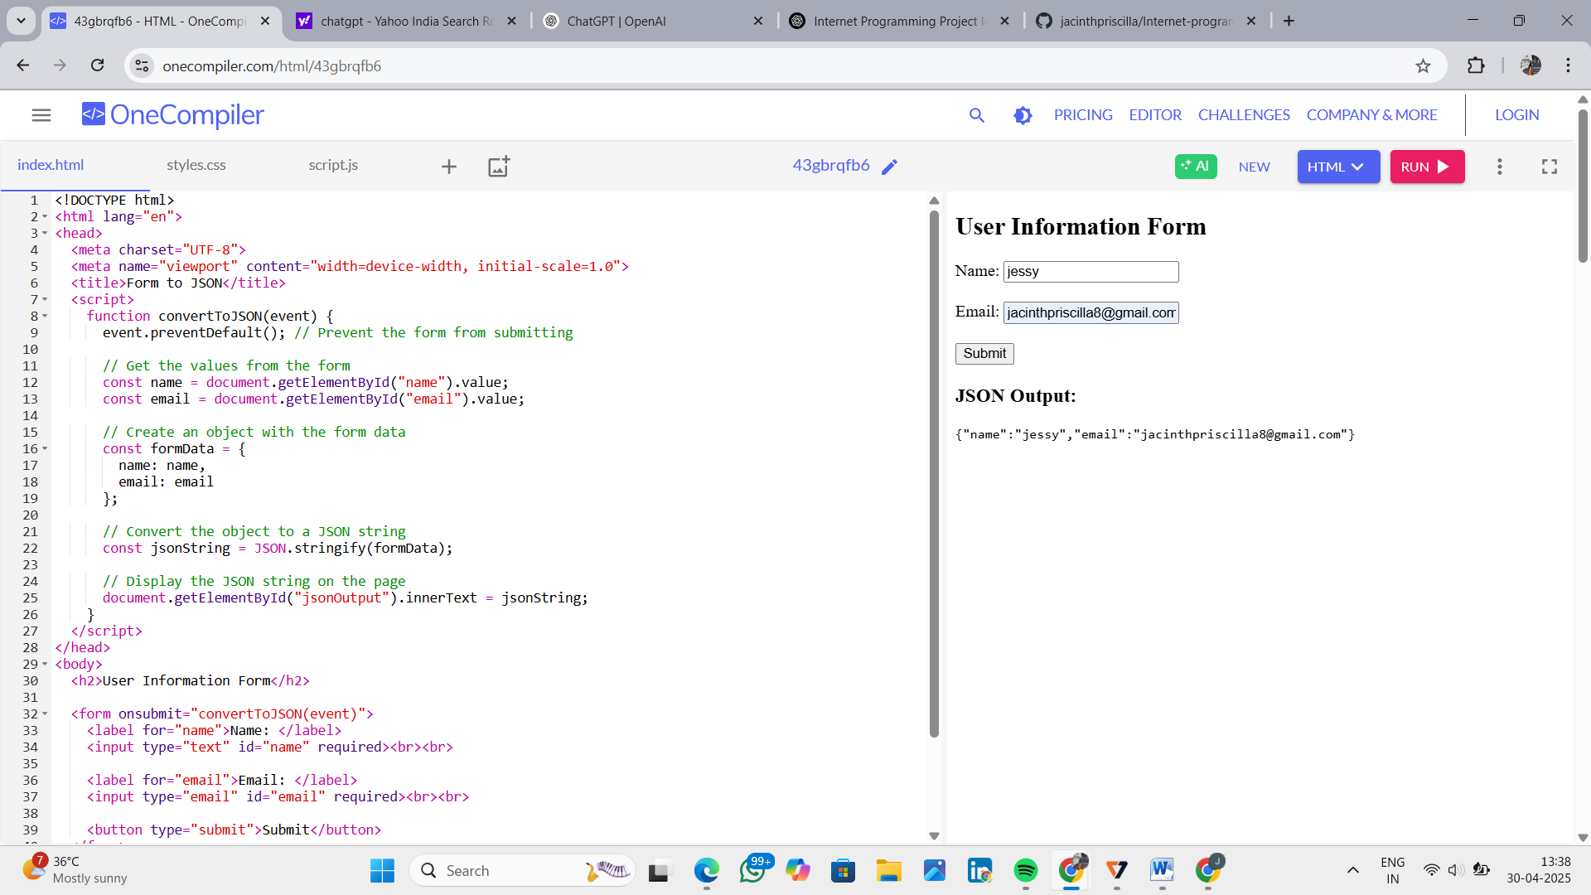

2a) HTML PAGE without paragraph and button

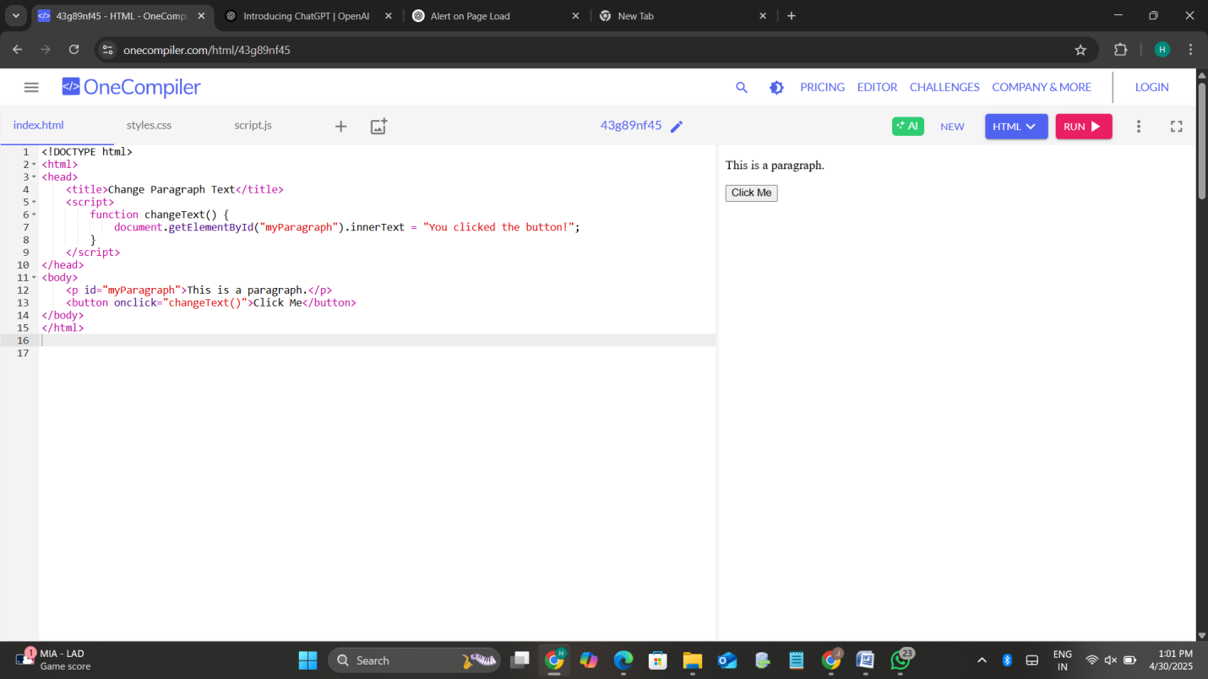

b) Form with username validation on submit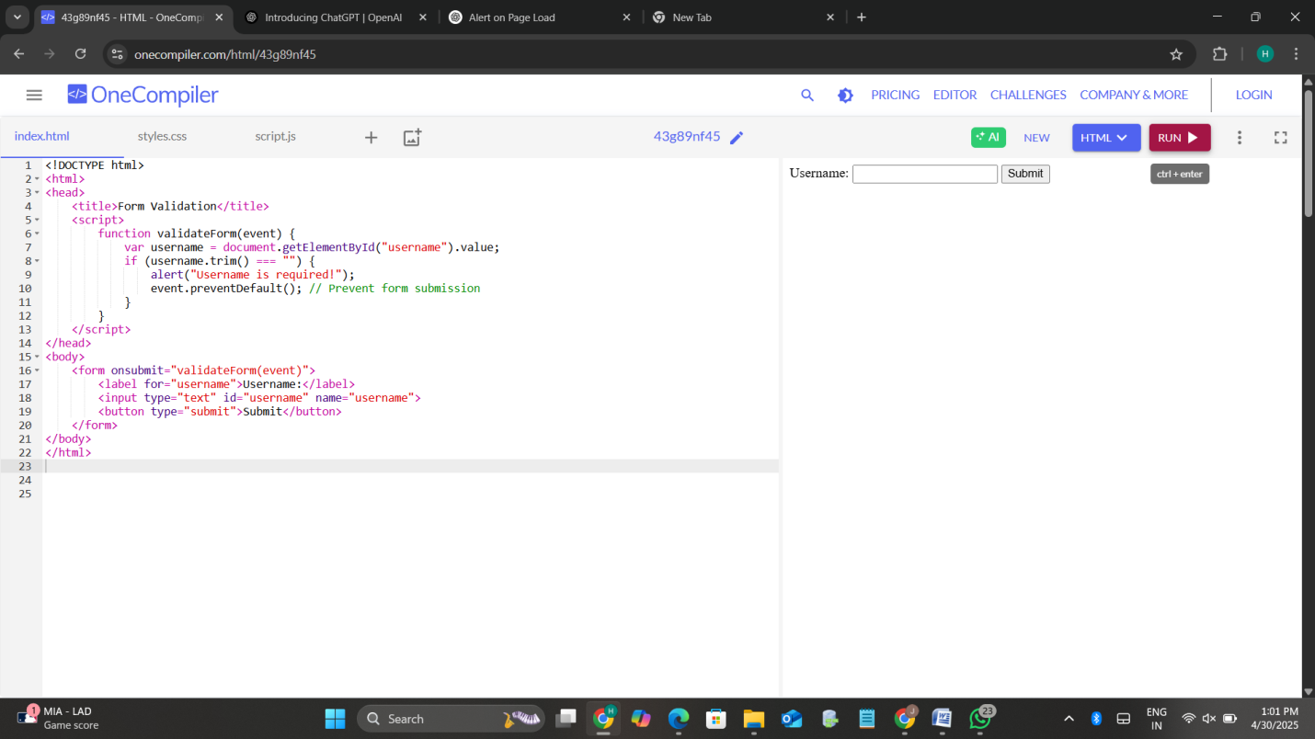

3a) Display current date and time in a <div> when the page loads

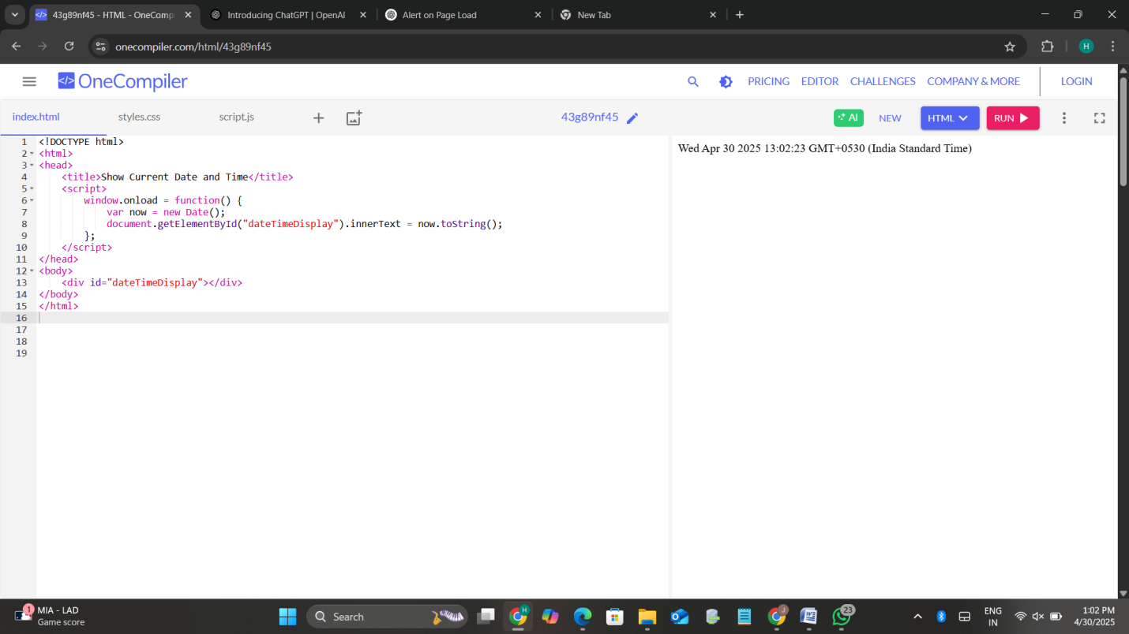

b) Create a simple digital clock using JavaScript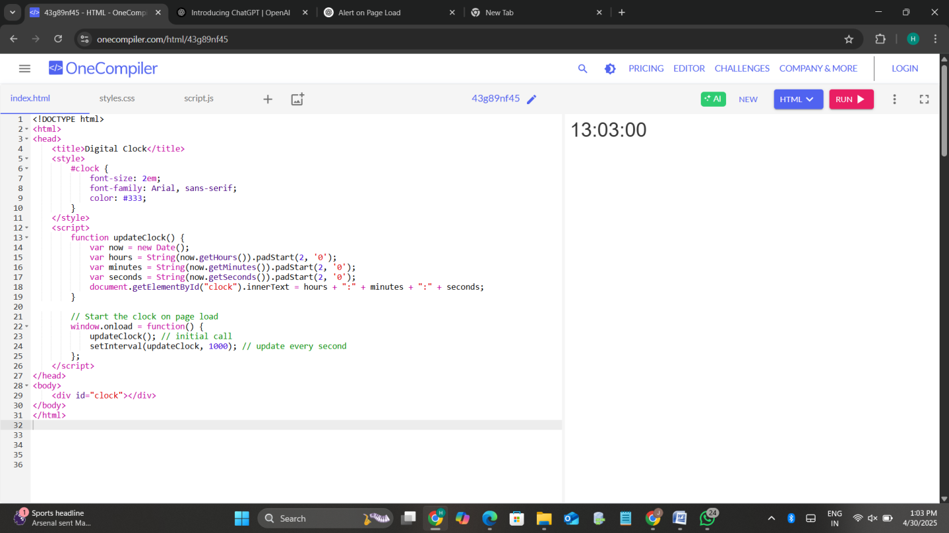

4) Email Validation Form with Regular Expression

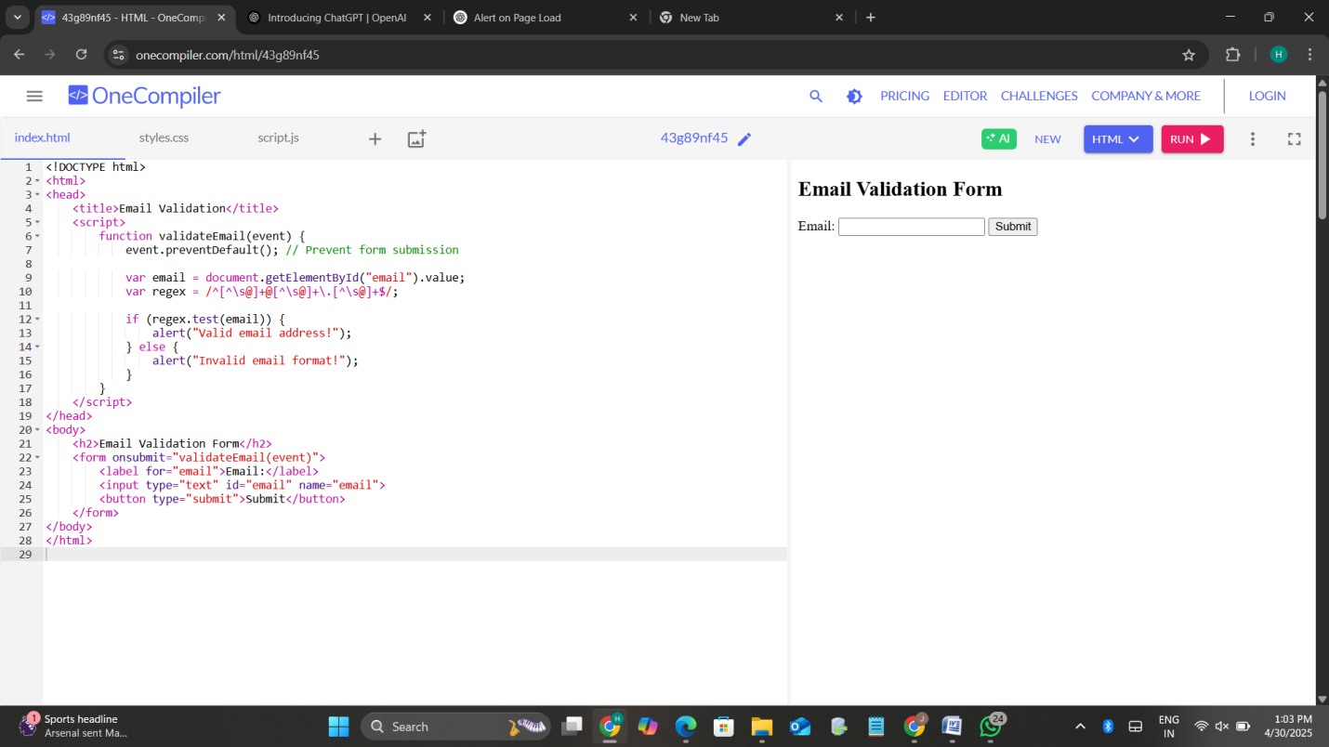

5a) Box that changes color on mouseover and reverts on mouseout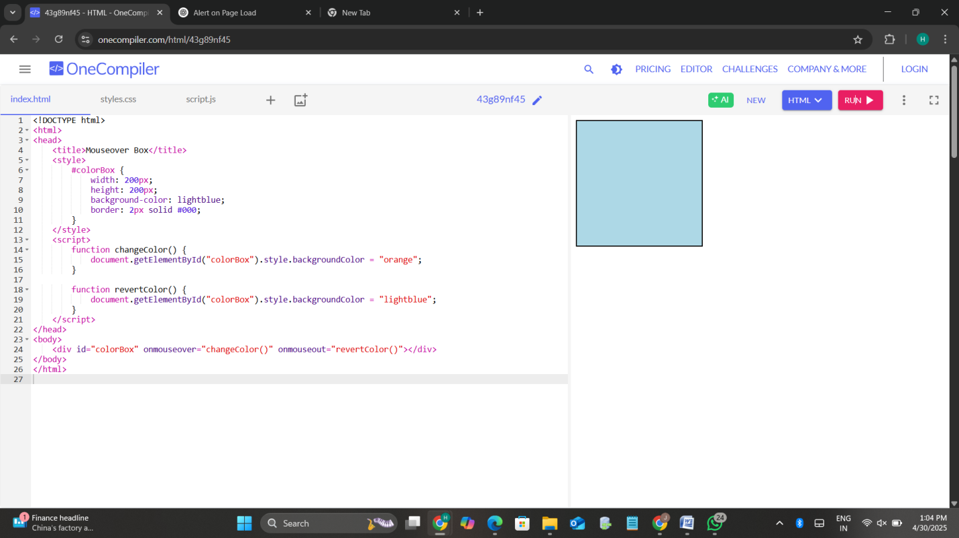

b) Image that smoothly increases in size when clicked (DHTML)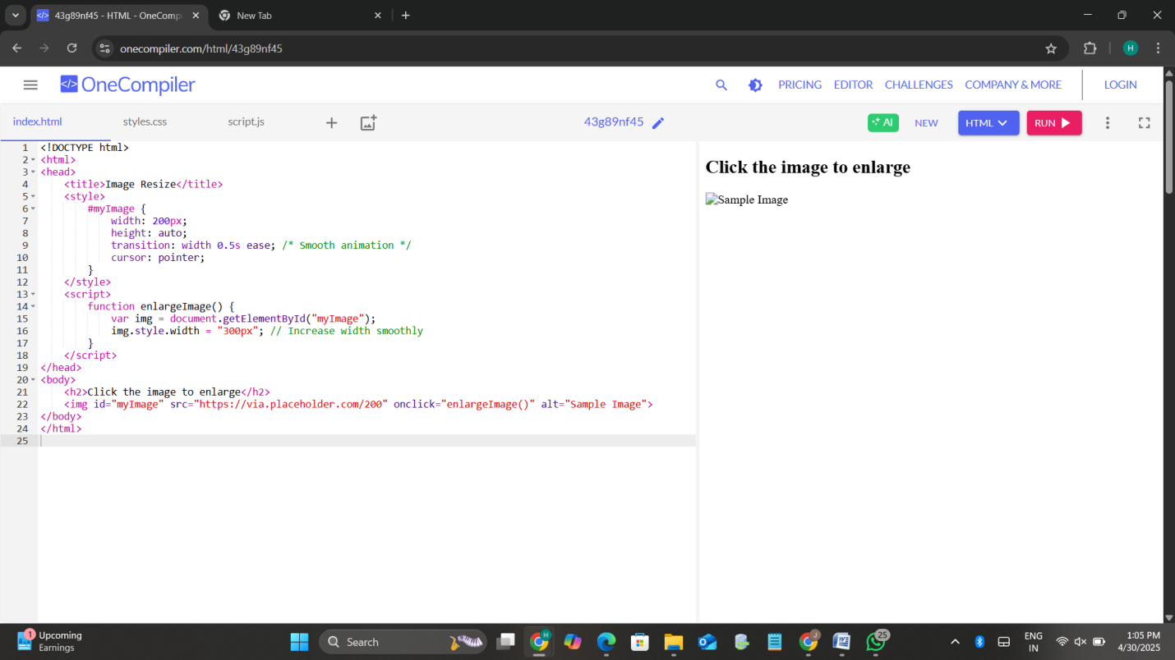

6. Exception Handling

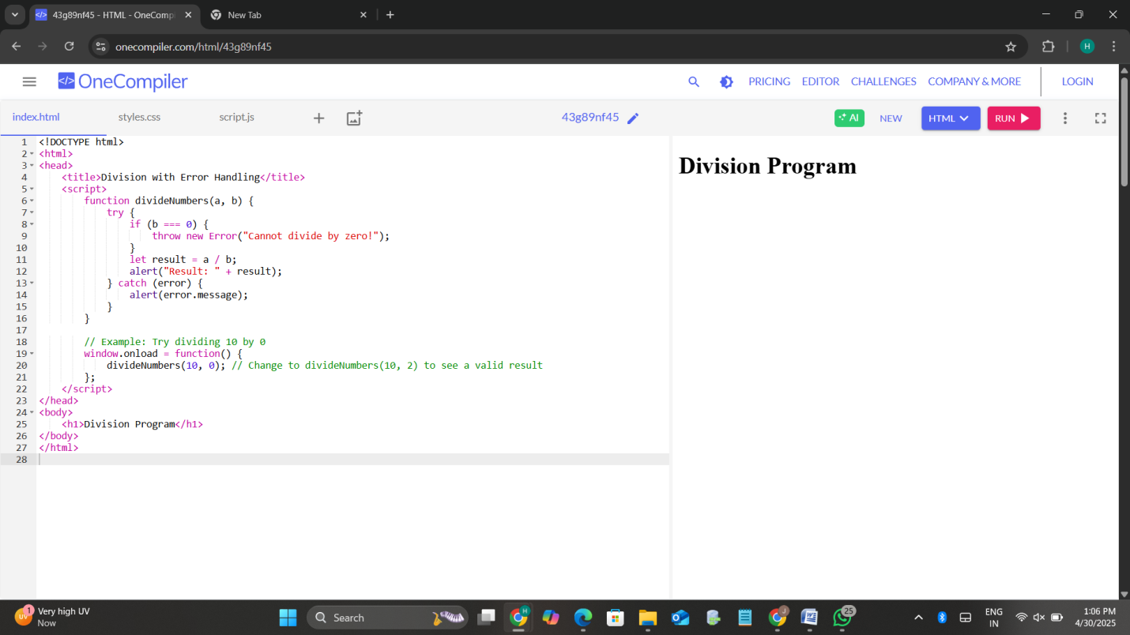

7. Square Root Calculator using JavaScript's Math Object

